NCERT 2021-22 [Page 204]

Fate of ammonia:

At physiological pH, the ammonia is protonated to form NH4+ (ammonium) ion. While most of the plants can assimilate nitrate as well as ammonium ions, the latter is quite toxic to plants and hence cannot accumulate in them. Let us now see how the NH4 + is used to synthesise amino acids in plants. There are two main ways in which this can take place:

1. Reductive amination : In these processes, ammonia reacts with α-ketoglutaric acid and forms glutamic acid as indicated in the equation given below :



1. Transamination : It involves the transfer of amino group from one amino acid to the keto group of a keto acid. Glutamic acid is the main amino acid from which the transfer of NH2, the amino group takes place and other amino acids are formed through transamination. The enzyme transaminase catalyses all such reactions. For example,

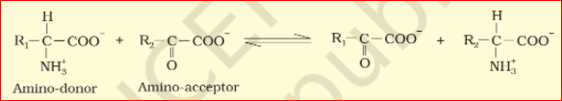

The two most important amides – asparagine and glutamine – found in plants are a structural part of proteins. They are formed from two amino acids, namely aspartic acid and glutamic acid, respectively, by addition of another amino group to each. The hydroxyl part of the acid is replaced by another NH2– radicle. Since amides contain more nitrogen than the amino acids, they are transported to other parts of the plant via xylem vessels. In addition, along with the transpiration stream the nodules of some plants (e.g., soyabean) export the fixed nitrogen as ureides. These compounds also have a particularly high nitrogen to carbon ratio.